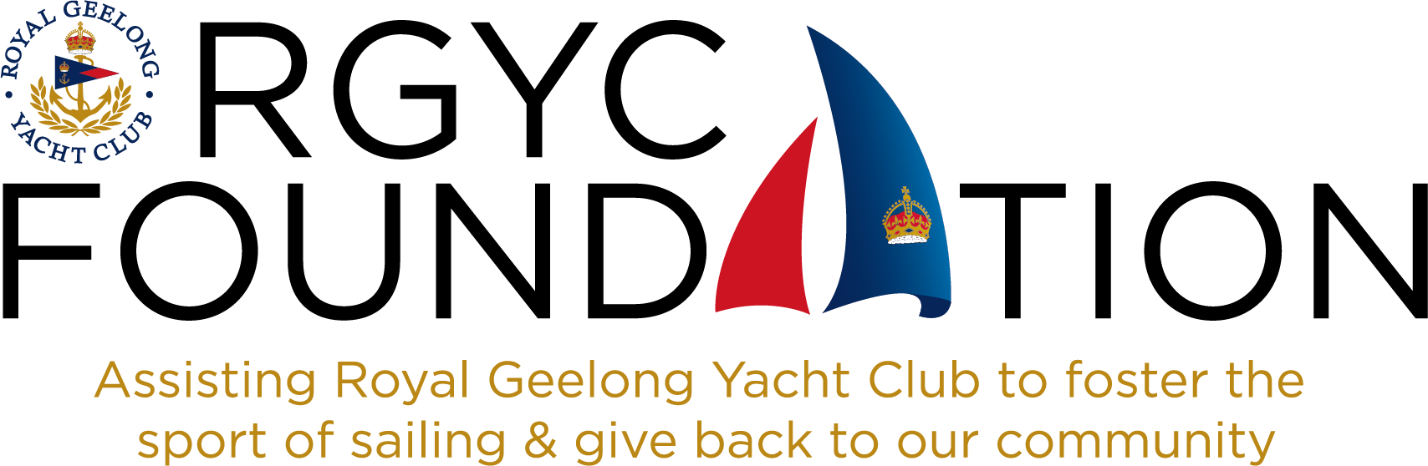

**AUTUMN (EIGHTH) QUARTERLY NEWSLETTER MARCH 31st 2025**

Dear Members of the RGYC Foundation.

It is with great pleasure that I write this newsletter some months since the Summer edition. Much has happened and great progress has been made.

Last Thursday evening we held the Robbie Miller dinner which was preceded by the Annual Get-Together which was missed last year. The Get-Together was well attended and it was pleasing to see many of those who could not get to the dinner come to join in the fun at the Get-Together. It is a very important event in our calendar as it draws Members together in a convivial atmosphere in order to share stories and hear about the progress of the RGYC Foundation.

Certificates of Membership were presented to Keryn Levick and Stuart Coffield and Brendan and Delia Lee joined that evening. This brings our new members to ten in the last year. We also heard from Conall Green who spoke with gratitude on behalf of the young RGYC sailors whom we supported in their various regattas last year. Cadet World Champion Josh Garner, who we supported in Plymouth, attended, along with his elder brother, Ben, who was Assistant Coach of the Australian Team and also Tony Bull who was Head Coach.

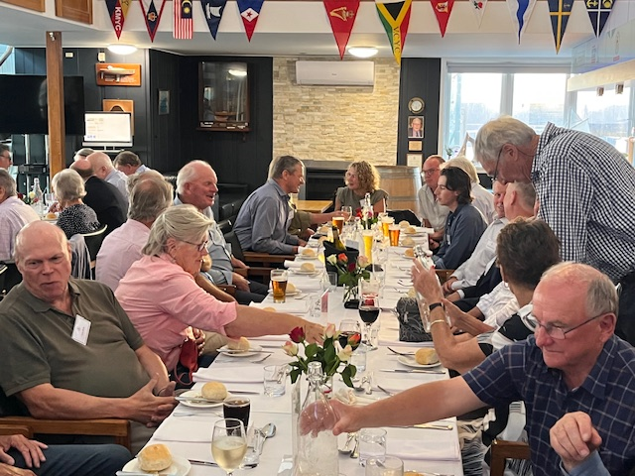

Our guest speaker at the Robbie Miller dinner was Foundation Member and RGYC Honorary Life Member Murray McRae. He took us on his 2016 adventure cruise with GEE Expeditions from South America to the Antarctic Peninsula. His talk showed his enthusiasm for the wildlife and the historical aspects of several South American cities as well as his interest in all aspects of the remote islands of the South Atlantic Ocean and the Antarctic Peninsula. He had many dramatic photographs and interesting anecdotes to go with them. Thank you, Murray for your entertaining and informative presentation.

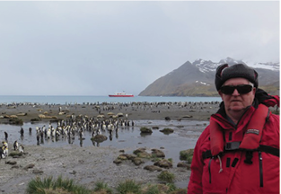 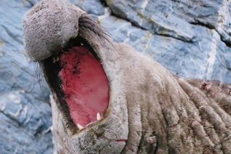

We continue to be very grateful to Foundation Member Paul Loughnan of European Affair for his regular and generous support of the Get-Together. We are also grateful for the sponsorship from Stuart Coffield of Geelong Travel, in association with Scenic Eclipse, of the Robbie Miller dinner. Alex Ruggero, from Scenic Eclipse, gave a presentation of the various cruises operated in the Antarctic region by Scenic Eclipse. These amazing cruise ships are light years ahead of the boat on which Murray completed his cruise nearly ten years ago. With Zodiacs, helicopters, huge stabilisers, highly energy efficient systems and many creature comforts, they are the pinnacle of this luxury cruising class.

We gave out numerous spot prizes at the dinner – a Five Times distilled Vodka and a Black Spiced Rum donated by Morgan and Jo Cornelius of Learning Organisation, several bottles of wine, courtesy of the Highton Bottle-Oh, a beautiful box of delicious chocolates from Hahndorf Chocolates of Pakington Street, Geelong West and, to balance the aforementioned indulgences, some two and three week memberships of the 10 South gymnasium in Fyans street, courtesy of Gerard Spriet. We are grateful for their support.

It has been pleasing to see RS 21 number 1 sailing out on Corio Bay with the RGYC Foundation banner on its topsides. It certainly has raised the profile of the Foundation in the club and with those who have used the RS 21 fleet for training, courses or corporate race days. It is also rewarding to feel that through our sponsorship of this boat we are contributing to programmes being run by the club to attract and retain members as well as improving the skills of current members, young and older.

As part of our RS21 Sponsorship ($11,000) agreement with RGYC we have one day when we have the use of all six RS21s, skippers and a rescue boat. After much deliberation it was agreed that we should invite Oberon Primary School Years 5 and 6 students to have a “Sailing Experience on Corio Bay”. Sixty-one students and eleven teachers had a memorable day. Of the students only 6 had ever been on a boat and NONE had been on a sailing boat. Within a few days quite a few students had signed up for a Tackers programme at RGYC. The Foundation Trustees see this as an important way to recruit new young members to RGYC and indeed, their parents. RGYC Foundation Hon. Secretary, Lynne Johnston is to be thanked and commended for her determination, enthusiasm and energy to make this experience happen for these Oberon students.

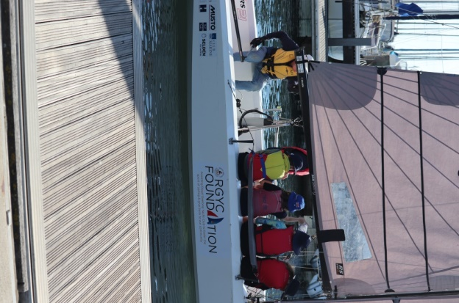

Foundation Chair, Jonathan Apted skippering RS 21 Number 1

“The Foundation” with Oberon students aboard

We are always interested in helping Foundation Members introduce others to join us in the RGYC Foundation. We are going through a period of significant growth – in memberships and in our finances. We encourage you to help us get more Members this financial year. Tax deductibility is available through our link with the Australian Sports Foundation. A donation of $1,050 will result in $1,000 coming to the Foundation and being recognised with membership. Can we join up another ten Members before the end of this financial year?

With all best wishes,

Jonathan Apted

Chair of Trustees